Information about data

From September – may there were 5 persons living together. The room 1 was a couple living there

**Wiser**

**Each apartment has their on login**

**WATCH THE VIDEO TO SEE HOW TO EXTRACT THE DATA PER HOUR**

Link: <https://app.schneider-electric.com/wiser-energy/#/landing>

wiserenergy1kth@hotmail.com

SchneiderWEKTH1

wiserenergy2kth@hotmail.com

SchneiderWEKTH2

wiserenergy3kth@hotmail.com

SchneiderWEKTH3

wiserenergy4kth@hotmail.com

SchneiderWEKTH4

For the layout here come some explanation to understand wiser

From the beginning there were 4 studios as the right picture below then last year we took away some walls and it became has the layout on the left. They were numbered 1-4 and that continued after the small reconstruction and the digital version wasn´t change due to be a small change and the sensors still stayed in the same place, THAT MEANS that digitally the boundaries are still the same from the beginning so look at room 1 and 2 includes a private bathroom each and a kitchen that is common and used by 5 persons and the room 3 and 4 2 includes a private bathroom each and a part of the living room that is common and used by 5 persons . This is to say that when you look into wiser, the data of the apartment 1 and 2 are the common kitchen you see on the layout 1, so the data from the apartment 1 is the data of the kitchen on the left and the apartment 2 is the kitchen on the right (to see appliances check the other word document) and the data for the apartment 3 and 4 is no longer kitchens, its living rooms, so probably you will only get data under the category “övrigt” and for the appliances that the students most had connected can be found in the other word

1. Layout September 2020- end of May 2021 2- layout before September 2020

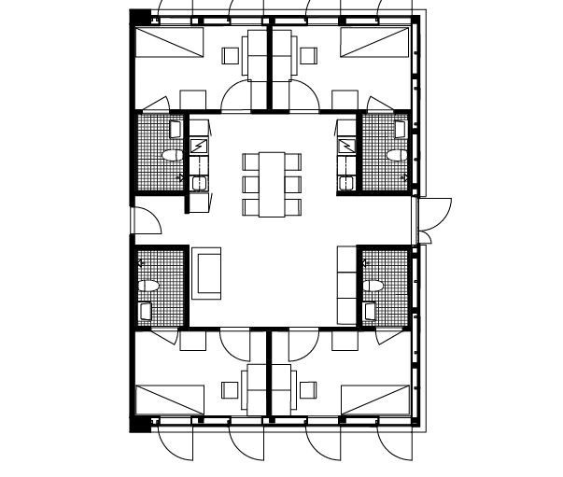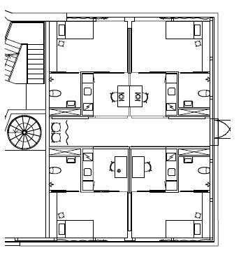

1

2

4

3

4

3

1

2

**When comes to EBO the main automation server that has the main data, I have tried to already divided under the right category.**

**The electricity from Schneider is the total electricity per “room” so you have to look at the same way that I n Wiser :** **room 1 and 2 includes a private bathroom each and a kitchen that is common and used by 5 persons and the room 3 and 4 2 includes a private bathroom each and a part of the living room that is common and used by 5 persons .**

**So the water for example for the room 3 and 4 is actually only for their bathrooms since there is no kitchen anymore. But for the the rooms 1 and 2 is included their bathroom but also the kitchens.**

**I have downloaded data from Labtrino ultrasound app, that it’s a project ongoing but they are also connected with EBO system and I also downloaded that so you compare, since sometimes one of the systems can be off due to some problem, but THEY ARE THE SAME DATA”**

**Below is the units of the sensors**

|  |  |  |
| --- | --- | --- |
| CO2 | Bathroom | ppm |
|  | Kitchen | ppm |
|  | Living room | ppm |
| Relative Humidity | Bathroom | % |
|  | Kitchen | % |
|  | Living room | % |
| Presure | LGHX-GP41 - Interval Trend Log | Pa |
|  | LGH1-GP42 - Interval Trend Log | Pa |
|  | LGH1-GP43 - Interval Trend Log | Pa |
|  | LGH1-GP44 - Interval Trend Log | Pa |
| Lights | Ceiling Lighting Living Room | % |
|  | Ceiling Lighting Kitchen | % |
|  | Kitchen lighting | % |
| Luminosity | Brightness Kitchen | LUX |
|  | Brightness Bathroom | LUX |
|  | Brightness Living room | LUX |
|  | Presence indication Bathroom | 1 or 0 |
|  | Presence indication Kitchen | 1 or 0 |
|  | Presence indication Living room | 1 or 0 |
| Temperature | Bathroom | °C |
|  | Floor Living room | °C |
|  | Interior wall 1 | °C |
|  | Interior wall 2 | °C |
|  | Kitchen | °C |
|  | Ceiling Living Room | °C |
|  | Outside | °C |
|  | Living Room | °C |
|  | Exterior wall 1 | °C |
|  | Exterior wall 2 | °C |
| Electricity | meter indication | kWh |
|  | Energy consumption the previous hour | kWh |
| Air quality-VOC | Living rom | % |

**Also when come to having same sensors in the same room in different excel lists it’s because they are in different positions, normaly one in on the left and one is on the right.**

**Some sensors have mistakes and may not be full data**